## G:\School Files\Bruche Primary\Business Manager\Certificates, badges, logos, signs\WPAT - Bruche logo - Sep 2021.jpgBruche Primary School AcademyG:\School Files\Bruche Primary\Business Manager\Certificates, badges, logos, signs\WPAT - Bruche logo - Sep 2021.jpg

Seymour Drive, Padgate, Warrington, WA1 3TT

Tel: 01925 815772

Executive Headteacher: Mr C Jones

School: [www.brucheprimary.co.uk](http://www.brucheprimary.co.uk)

Multi academy trust: wpat.warrington.sch.uk

Bruche.office@wpat.uk

@Bruche_P_School

Welcome to the last newsletter of the academic year! What a year it has been!

Our wonderful year 6 children leave today, and we will miss them all! This morning, they produced a fantastic leavers assembly for their parents and although it was sad to know this was their last day at Bruche we were all so proud of them! It was so pleasing to watch how confident and articulate they all were even through the tears! Thank you to everyone who came along, it was lovely to speak to so many of you. I have shared their SAT’s results below which the children are very proud of. Finally, I’m sure you will all join me in wishing them the very best of luck at their high schools. Remember year 6,

***This is not goodbye, but Bonjour*** and ***Nil satis nisi optimum!***

Percentage of children achieving the Age Related Expectations in reading, writing and maths combined = 97%

Percentage of children achieving Greater Depth understanding in reading, writing and maths combined = 30%

Percentage of children in receipt of pupil premium achieving Age Related Expectations in reading, writing and maths combined = 100%

The Bruche staff have asked that I pass on their thanks for their wonderful end of year presents, it is very kind of you all.

All that’s left now is to say thank you for all your support, kind words and encouragement this year and I hope you all have a great summer break! See you all on Wednesday 4th September 2024!

Best wishes and take care.

Mr Jones

Communication Corner

**Diary Dates**

02/09/2024 Inset Day

03/09/2024 Inset Day

04/09/2024 Children back in school

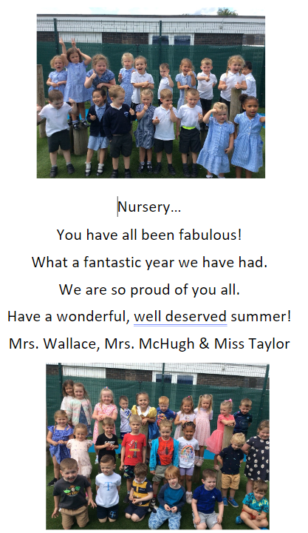

Nursery

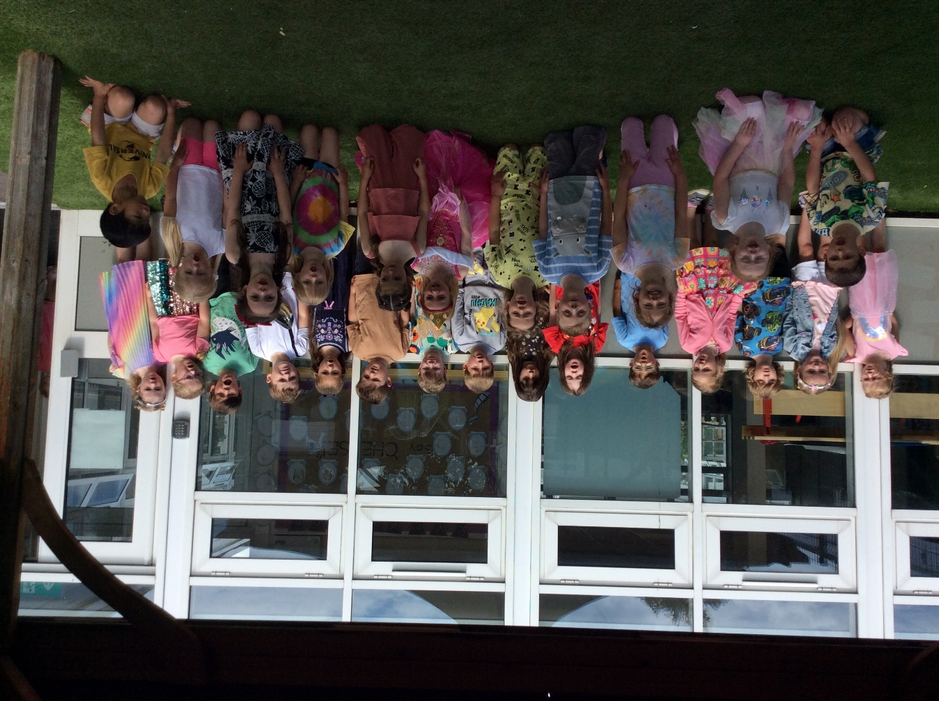

Reception

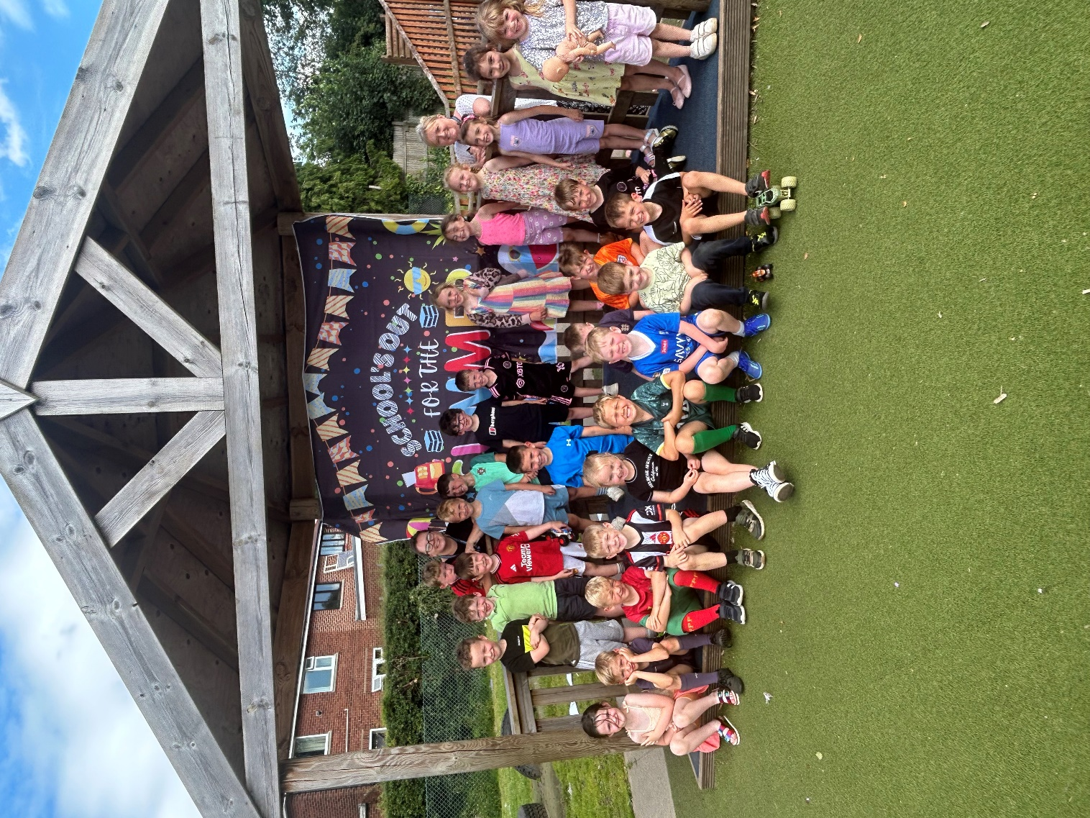

Year 1



Year 2



Year 3



Year 4



Year 5 45

Class of 2024

Year 6





**BRUCHE PRIMARY SCHOOL**

Term Dates 2024-2025

|  |  |  |
| --- | --- | --- |
|  | **Closing Date** | **Opening Date** |
| Autumn 2024 |  | 04.09.24 |
| Autumn Half Term | 18.10.24 | 04.11.24 |
| Christmas 2023 | 20.12.24 | 06.01.25 |
| Spring Half Term 2024 | 14.02.25 | 24.02.25 |
| Easter | 11.04.25 | 22.04.25 |
| Bank Holidays (Good Friday and Easter Monday) | 18.04.25 and 21.04.25 | |
| Bank Holiday (May Day) | 05.05.25 | |
| Summer Half Term | 23.05.25 | 02.06.2025 |
| Summer 2024 | 18.07.25 | 03.09.25 |

**INSET** (Training days for staff – children not in school)

|  |  |
| --- | --- |
| **INSET 1** | 02.09.24 |
| **INSET 2** | 03.09.24 |
| **INSET 3** | 27.06.25 |
| **INSET 4** | 21.07.25 |
| **INSET 5** | 22.07.25 |

|  |  |
| --- | --- |
| **Holiday Dates** | |
| October Half Term | 18.10.24 – 03.11.24 |
| Christmas Holiday | 20.12.24 – 05.01.25 |
| February Half Term | 14.02.25 – 23.02.25 |
| Easter Holiday | 11.04.25 – 21.04.25 |
| May Half Term (Whit) | 23.05.25 – 01.06.25 |
| Summer Holiday | 18.07.25- 03.09.25 |



**BRUCHE PRIMARY SCHOOL**

Term Dates 2025-2026

|  |  |  |
| --- | --- | --- |
|  | **Closing Date** | **Opening Date** |
| Autumn 2024 |  | 03.09.25 |
| Autumn Half Term | 17.10.25 | 03.11.25 |
| Christmas 2024 | 19.12.25 | 05.01.26 |
| Spring Half Term 2024 | 13.02.26 | 23.02.26 |
| Easter | 02.04.26 | 13.04.26 |
| Bank Holidays (Good Friday and Easter Monday) | 03.04.26 and 06.04.26 | |
| Bank Holiday (May Day) | 04.05.26 | |
| Summer Half Term | 22.05.26 | 01.06.26 |
| Summer 2025 | 17.06.26 | (TBC) |

**INSET** (Training days for staff – children not in school)

|  |  |
| --- | --- |
| **INSET 1** | 01.09.24 |
| **INSET 2** | 02.09.25 |
| **INSET 3** | 03.07.26 |
| **INSET 4** | 20.07.26 |
| **INSET 5** | 21.07.26 |

|  |  |
| --- | --- |
| **Holiday Dates** | |
| October Half Term | 20.10.25 - 31.10.25 |
| Christmas Holiday | 22.12.25 – 02.01.26 |
| February Half Term | 16.02.26 – 20.02.26 |
| Easter Holiday | 03.04.26 – 10.04.26 |
| May Half Term (Whit) | 25.05.26 – 29.05.26 |
| Summer Holiday | 20.07.26 - TBC |

