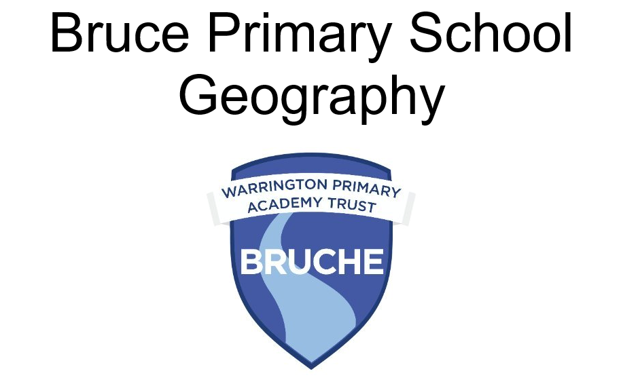

POLICY DOCUMENT

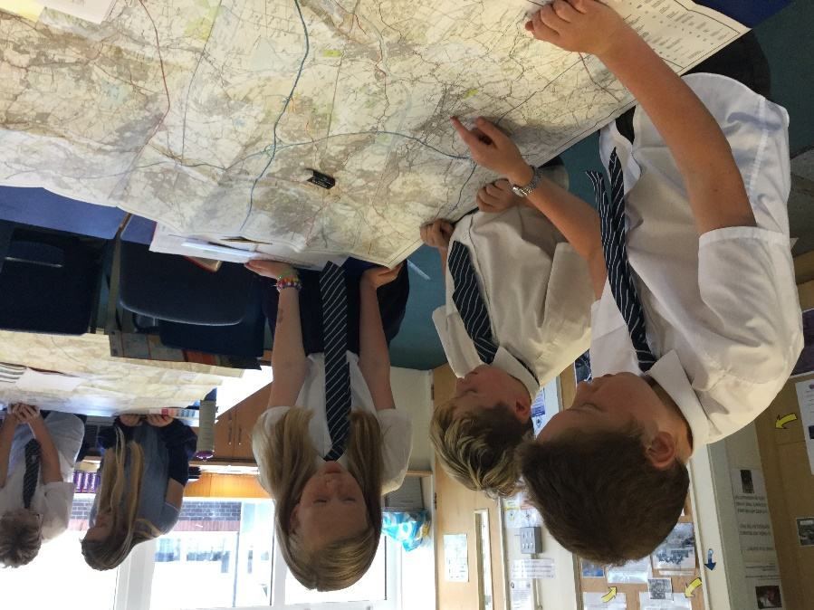
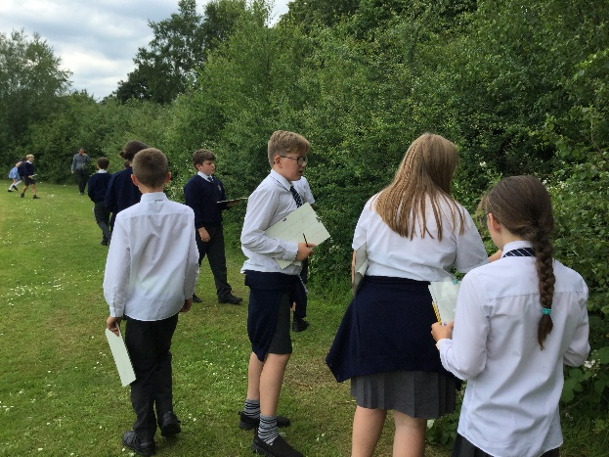
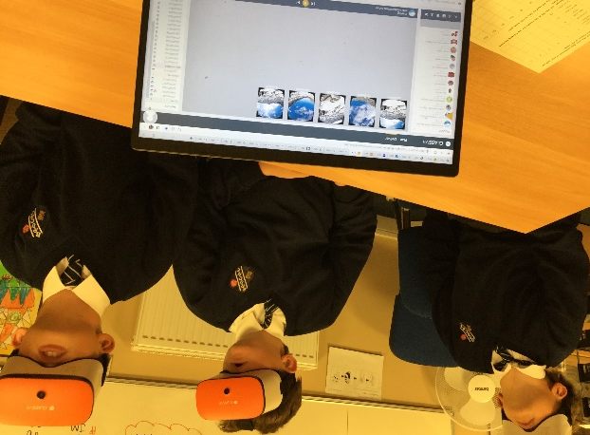
Updated – May 2024
Geography’s 7 big concepts | Concepts briefly summarised
Place | Concept encompasses real and imagined place and refers to:  - what is in places and what happens there  - ways places change and develop  - their character and what they are like  - how we conceive of and respond to places  - whether we prefer them to stay the same or evolve  - place is multifaceted involving cognitive and affective understanding of places
Scale | Concept provides the lens to look at the world, from very small sites to local, regional, national, continental and oceanic areas, to the whole world  - Scale enables many relationships to be identified and particular and wide ranging patterns and connections to be identified  - Scale supports understanding environmental and place processes and making predictions
space | Concepts refers to where features and places are located, their distribution, the patterns they form and the networks connecting them  - Space describes the formal layout of the natural and human environment and their fluidity and change  - It enables us to recognise and explain the processes affecting them
Environmental (physical and human processes) | Concept relates to the land and oceanic surface of the earth, its geology and its atmosphere  - It includes the Earth’s range of natural and people created features, and the natural and human actions affecting the world  - It explains the processes that create and change natural, built, modified and social environments  - This concepts helps us to predict and plan what might happen
Interconnections | Concepts refers to nature and significance of links between features, places, events and people  - It enables recognition and appreciation of interdependence, locally, regionally or globally, whether ecological or socially generated  - It examines the importance and impact of maintaining, modifying or breaking interconnections
Environmental impact and sustainability | Concept concerns the interactions between the natural and human environments and their effects on each other, particularly of change and its consequences  - It examines the quality, management and care of environments, places and lives  - It considers the responsible and exploitative uses of the Earth’s resources alongside responses to the degrading of natural and modified environments and damage to people’s lives  - It considers ways to improve people’s futures and Earth, and the ethics of doing so
Cultural awareness and diversity | Concept encompasses local and global diversity and the disparities in and of people’s lives and communities and their connections to the natural world  - It encompasses social and cultural interests and the dynamics in shared, common and different ways in which people use environmental resources, adapt places, interact and value and modify or conserve their local and national cultures, places and identities

Substantive Knowledge
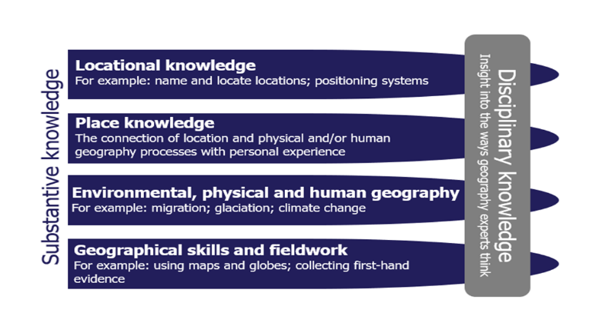

Disciplinary knowledge Substantive Knowledge
This considers how geographical knowledge originates and is revised. It is through disciplinary knowledge that pupils learn the practices of geographers and begin to ‘think like a geographer’
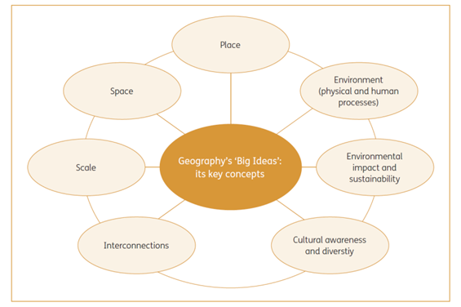

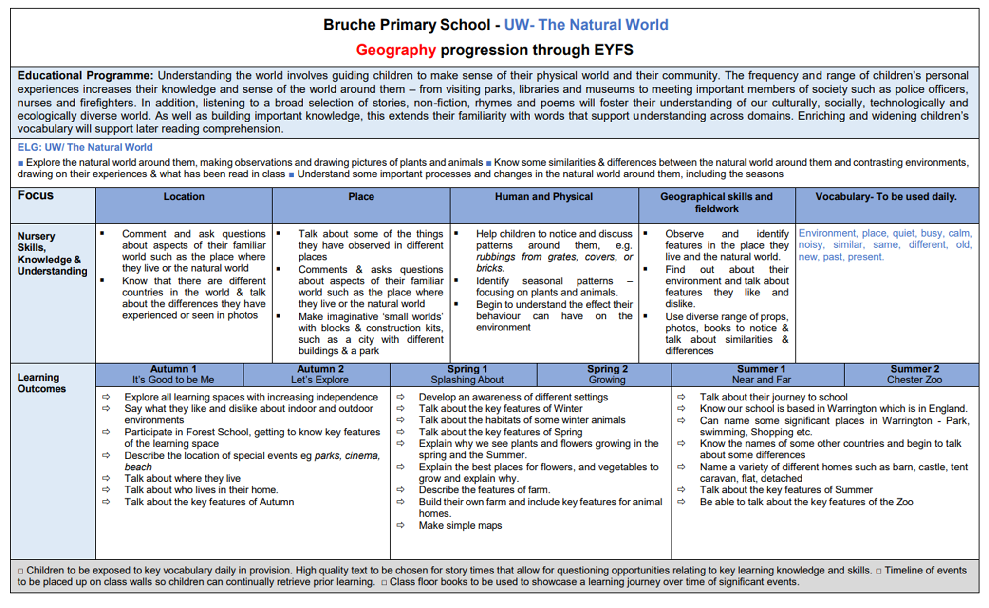

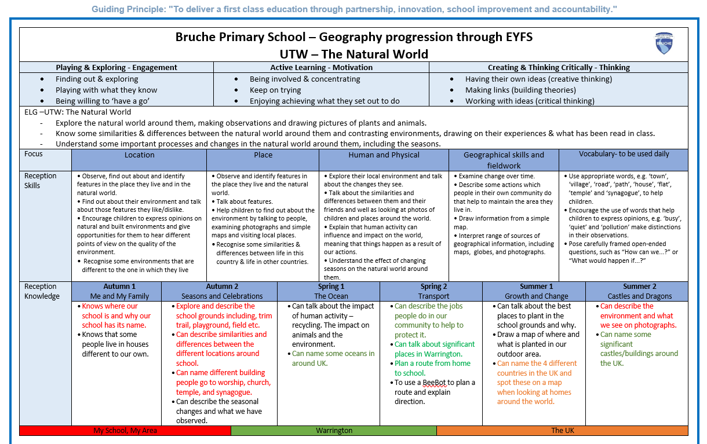

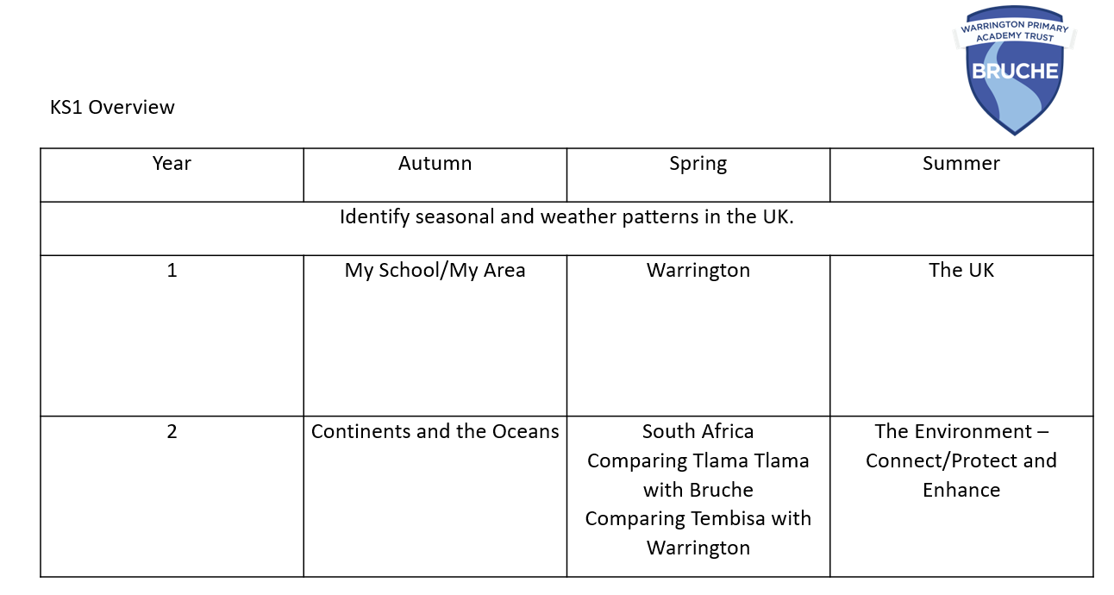

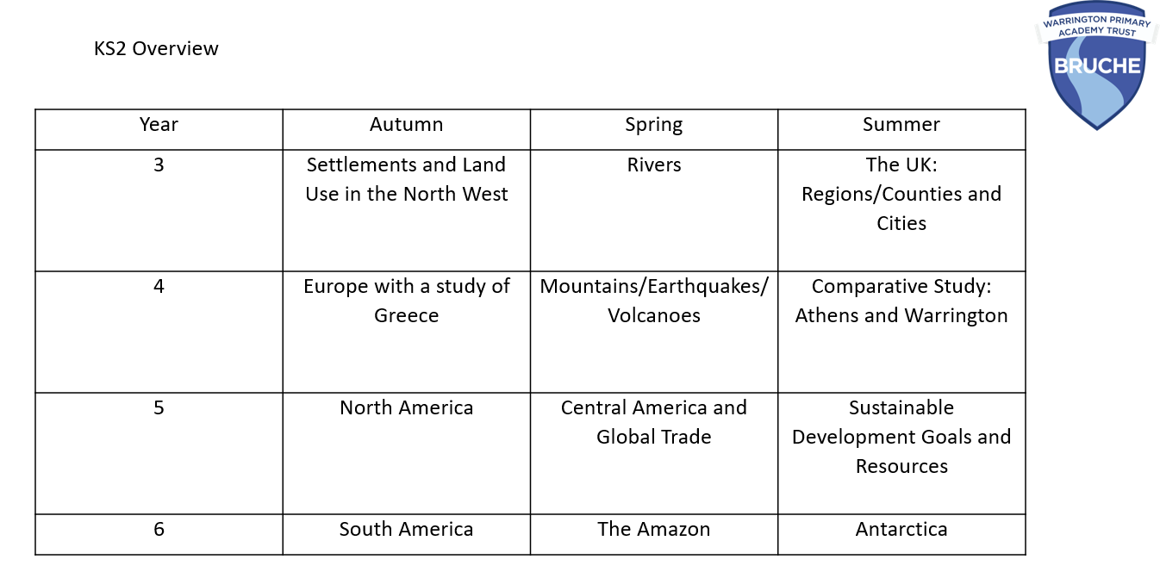

Bruche Geography Aims:
The aims of Geography at Bruche are:
- To inspire in pupils about the World and its people that will remain with them for the rest of their lives.
- To provide pupils with knowledge about diverse places, people, resources and natural and human environments.
- To develop a growing knowledge about the World to deepen children’s understanding of the interaction between physical and human processes, and of the formation and use of landscapes and environments.
- For pupils to obtain Geographical knowledge, understanding and skills.
- To enable children to learn and explain how the Earth’s features at different scales are shaped, interconnected and change over time.
- To make interconnections within and across topics.
- To analyse problems across the World, establishing cause and consequence and coming up with solutions.

Our Geography Curriculum:
Our Geography curriculum is designed to develop children’s curiosity and fascination about the World and its people that will remain with the children for the rest of their lives. Children investigate a range of places – both in Britain and abroad – to help develop their knowledge and understanding of the Earth’s physical and human processes.
- Children learn that Geography is always changing and that studying and educating others about causes/consequences and solutions to problems can help make a positive difference to our World – at Bruche, we want our children to be bothered and passionate about their environment and the World in which they live.
We are committed to providing children with opportunities to investigate and make enquiries about their environment and local area, so that they can develop of real sense of who they are, their heritage and what makes our local area unique and special.
We have collaboratively planned a progressive whole school fieldwork curriculum journey to ensure children get the opportunity to use and apply the skills and knowledge that they acquire in the classroom and gain a deeper understanding.
We want to develop the children’s ability to apply geographical skills to enable to confidently communicate their findings and geographical understanding to a range of audiences.
Our Geography curriculum is broad and balanced and well-sequenced – we have been collaborative and proactive in our thoughts when designing an interleaving knowledge rich curriculum which is sequenced effectively to allow learning to build upon learning, thus allowing children’s working memories to work to their full potential, allowing understanding to be deepened, session upon session. We understand that embedding knowledge that is worth having will make children better citizens - enquiry will be question lead and will be scaffolded according to Rosenshine’s principles
We understand that we need to provide a quality diet for all of children, realising that everyone’s prior home experience will be different.
Our ambitious curriculum covers the 7 key concepts of Geography – we understand that Geography is constantly evolving as are our plans.
The seven geographical concepts of place, space, environment, interconnection, sustainability, scale and change are the key to understanding the places that make up our World. Other content based concepts such as weather, climate, mega cities and landscapes form the rest of our Geography offer.

Essential Geographical Characteristics We Develop at Bruche:
Through high quality teaching, we aim to develop the following essential characteristics of geographers:
- An excellent knowledge of where places are and what they are like, both in Britain and the wider world;
- A comprehensive understanding of the ways in which places are interdependent and interconnected
- An extensive base of geographical knowledge and vocabulary;
- The ability to reach clear conclusions and explain their findings;
- Excellent fieldwork skills as well as other geographical aptitudes and techniques;
- The ability to express well-balanced opinions, rooted in very good knowledge and understanding about current issues in society and the environment;
- A genuine interest in the subject and a real sense of curiosity about the World and the people who live here.
- Curiosity to look at cause and consequence and aspire to find solution

Fieldwork at Bruche:
It is encouraged that teachers plan opportunities to use the school grounds, local environment and going further afield to conduct geographical fieldwork. When sessions lead to leaving the school grounds staff must adhere to the Warrington Authority Risk Assessment procedures using Evolve. Any water activities or work near water requires at least 10 weeks’ notification and application prior to the visit.
Fieldwork opportunities allow children to collect data, answer questions, analyse situations, represent data and find solutions to problems. Depended understanding of human and physical processes are enhanced by fieldwork opportunities with children given ample opportunity to use technology to represent collected data.
Impact of our curriculum:
The impact of our curriculum is strong. Regular, termly monitoring through pupil voice shows great retention of key knowledge and children are able to make connections between and across topics.
Regular observations of lessons and book scrutiny show fidelity to the curriculum and assessment end points are clear and evidenced in workbooks through end of unit low stakes/high impact, multiple choice quizzes.
At Bruche, there is sufficient breadth of learning and depth of learning. Topics are inter-related, allowing children to make comparison, remember more, understand more. Small steps are used and prior knowledge is always built on, so that pupils working memory is not over-loaded. A near (personal experience)/far structure is carefully built allowing children to develop locational fluency. Place knowledge, built over time, allows children to make comparisons and build place connections. Physical and human processes are well planned allowing children to develop inter-connectedness
Beginning in EYFS, our sequential curriculum builds on knowledge and thematic approach is made, leading to children remembering more/understanding more: ending with our final concept of ‘How Can We Save the Planet and Reduce Climate Change?’ Our carefully planned opportunities allow learning to help pupils become better citizens
We encourage our children to think critically and come up with solutions to make the World a better place, bringing the curriculum to life – cause/consequence/solution and over-arching questions are built in to ensure that misconceptions are not made: ‘Is South America all covered in rainforest?’ avoiding portraying a single story
Through the Bruche Geography curriculum, goals become more and more challenging and abstract and children are encouraged to question/debate/solve problems/empathise, giving children numerous opportunities go well above and beyond the requirements of the NC. Our ambitious curriculum carefully covers the 7 key concepts of geography – we understand that Geography is constantly evolving as are our plans.
The seven Geographical concepts of place, space, environment, interconnection, sustainability, scale and change are the key to understanding the places that make up our world and other content based concepts such as weather, climate, mega cities and landscapes form the rest of our Geography offer. At Bruche, VRs are used effectively to ‘visit’ places across the World
Connections are further embedded through use of Topical Talk, Picture News, Computing, Forest School, Science and WCSR

Geography Retrieval Opportunities at Bruche:
Numerous opportunities for retrieval are made at Bruche including:
- Morning Challenge
- Quizzes linked to end points – low stakes/high impact
- Crosswords and word searches linked to endpoints
- Class VRs
- Learning by Questions – homework/lessons
- Click View videos – homework/lessons
- Mid-point and end point assessments
- Lesson recaps on end points covered/ Regular recaps from previous topics/years during morning challenge and lesson recaps
- Marking responses – last year/last month/last week
- Geoguesser app for place and location knowledge
- Handwriting practice

Bruche Geography and SEND
- With Geography at Bruche, we plan and make reasonable adjustments for SEND, which include:
- simplification of text
- targeted questioning
- subject specific word banks
- matching activities rather than writing
- over explanation and additional questioning using simpler vocabulary.
- memory activities – matching cards to locations/biomes linked to a topic to aid retrieval of locational or other key subject knowledge
- working walls - vocabulary, images and facts displayed on working walls and refer to these regularly - encouraging children with SEN to use these if they are unsure in lessons.
- sentence starters/enders/relative clauses
- multi-sensory approaches, including information and communication technology (ICT)
- working with additional adults
- managing peer relationships
- memory/consolidation and additional retrieval
These supports and adaptations ensure all our children have full access to our ambitious broad and balanced curriculum.

Spiritual, Moral, Social and Cultural opportunities
Geography is an excellent vehicle for developing children’s learning in this area. Discussions about the use of the world’s resources and the impact of different events on the lives of local people deepen the children’s ability to understand and empathise with fellow humans across the globe. The opportunities to explore ‘putting yourself in someone else’s shoes’ abound in the study of Geography and itis embraced during the teaching wherever possible.

The role of the Bruche Geography Coordinator
The Geography co-ordinator leads the maintenance and development of the subject. They are responsible for assuring quality and standards in the subject by:
• Taking the lead in the development, evaluation and amendment of schemes of work as and when necessary.
• Identifying training needs of staff through monitoring and performance management review.
• Acting as a consultant to colleagues on resources, fieldwork possibilities, curriculum changes, classroom teaching ideas.
• Monitoring and evaluating pupils’ work and classroom teaching.
Geography Health and Safety
The School’s policy for visits and excursions will be adhered to for all trips. This is supplemented with local authority guidance concerning educational visits.
Geography Equal Opportunities
We believe that all children, irrespective of background, race, gender and capability, should have equal access to the curriculum. The school makes every effort to respect and reflect pupils’ religious beliefs and take community views into account when teaching Geography.

